Title of the Document: | Reference Lines in Tableau(17-07-2019)
Author: | Prepared by Uma Devi
Project Name:

Table of Contents
reference lines,bands,distribution,box plot………………………………………………………………………1
Create Reference lines,edit lines,band,distribution,box plot ….…………………………………...2
Remove lines,bands,distribution,box plot………………………………………………………………...3

Reference lines

Reference lines, Bands, Distribution and Boxes:

Reference Lines:
Add a reference line, band, distribution or box plot to mark a specific value or region on an axis. For example, if you are analyzing the yearly sales for several products, you may want to include a reference line at the average sales mark so you can see how each product performed against the average. Alternatively, you may want to shade a particular area along the axis, show a distribution, or show the full range of values, using a box plot.
Tableau lets you add an unlimited number of reference lines, bands, distributions, and box plots. Right-click (control-click on a Mac) on an axis and select Add Reference Line to open the Add Reference Line, Band, or Box dialog box:
Right click on the axis and click on the →Add reference lines
Once we select the Add Reference Line option, a new window called Add Reference line, Band or Box will opened to configure the reference lines. So this is lines we can select the line option.
We have three options
1. Entire Table
2. Per Pane
3. Per Cell
→Entire Table: If we select entire table option, Tableau will calculate aggregation for entire table and add Reference line to the entire table.
→Per Pane: If we select Per Pane Option then, Tableau will calculate aggregation for individual panes inside the table and add reference line to the individual pane.
→Per Cell: If we select this option, Tableau will calculate aggregation for individual cell inside the table and add reference line to the individual cell.

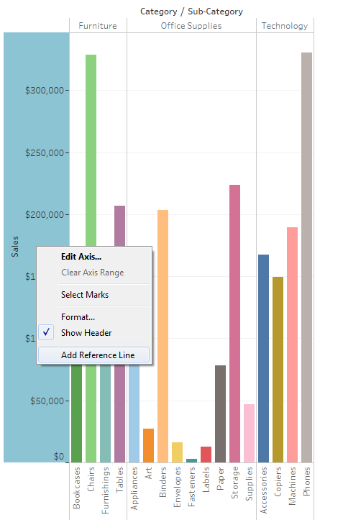
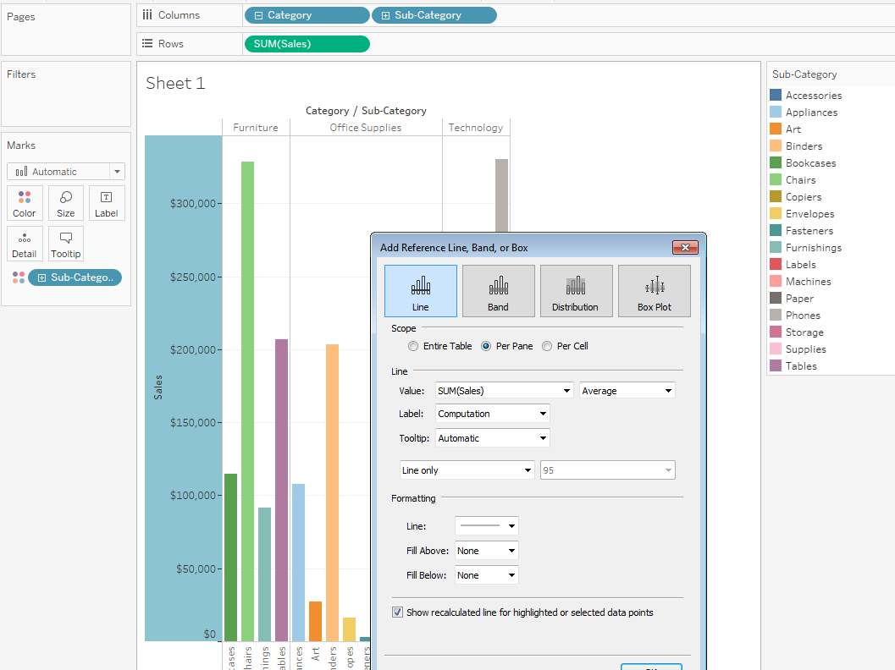

Add Reference Line to the Entire Table:
If we click on the entire table option and the value will be sum (sales) and average sales per entire table, here we have shown on the Average line of entire table in chart.
We have Maximum, Minimum, Average, Sum, Total, aggregations will be like that.
- Total: This option will place a line at the aggregate of all the values of a selected Measure (here it is, Sales Amount)
- Sum: This option will place a line at the Sum of selected Measure (here it is, Sales Amount)
- Constant: This option will place a line at the Specified Constant value
- Minimum: This option will place a line at the Minimum of selected Measure (here it is, Sales Amount)
- Maximum: This option will place a line at the Maximum of selected Measure (here it is, Sales Amount)
- Average: This option will place a line at the Average of selected Measure (here it is, Sales Amount)
- Median: This option will place a line at the Median of selected Measure (here it is, Sales Amount)
To add a reference line:
- Drag Reference Line from the Analytics pane into the view. Tableau shows the possible destinations. The range of choices varies depending on the type of item and the current view.

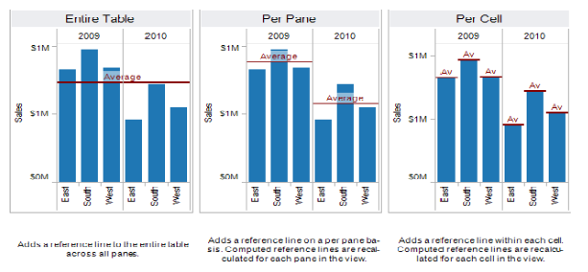

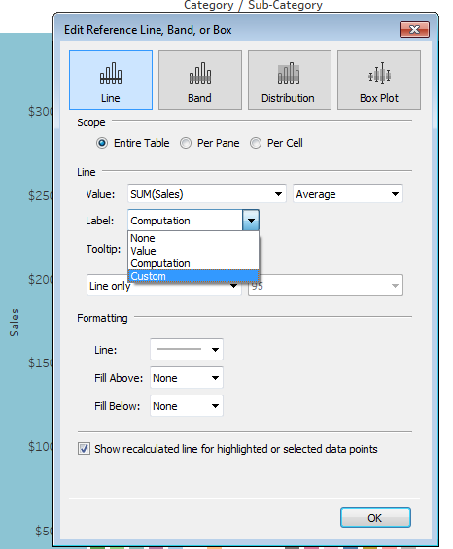
Here we have option for Label None, Value, Computation, and Custom
- None –select this option to not show a label for the reference line.
- Value – select this option to show a label corresponding to the line's value on the axis.
- Computation – select this option to display the name of the continuous field that is the basis for your reference line and any computation that is performed.
- Custom – select this option to build a custom label in the text box. You can use the menu to the right of the text box to insert values such as the computation or the value. You can also type text directly into the box, so you could create a value such as <Field Name> = <Value>.

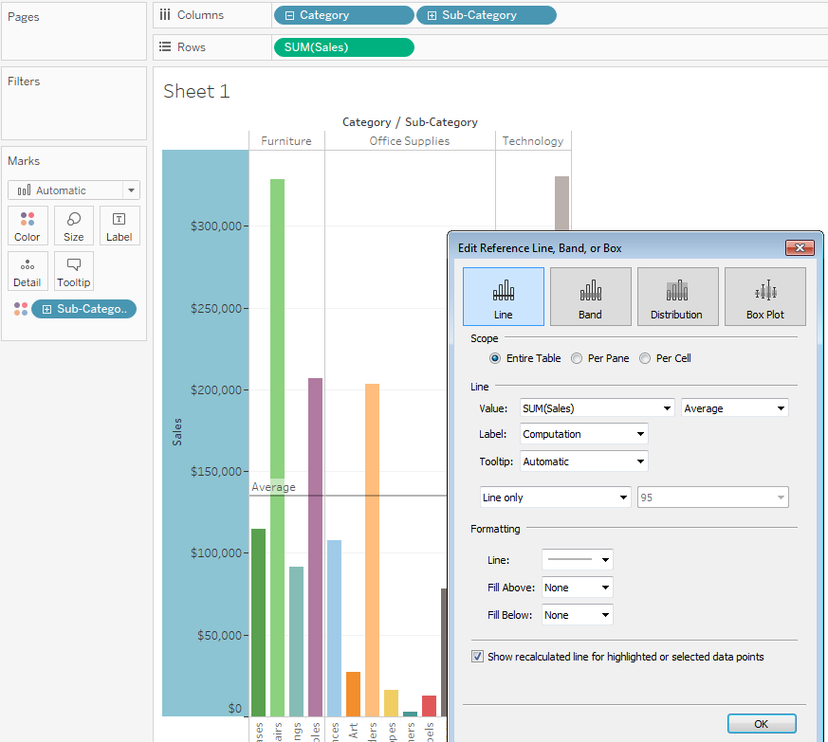
Here Average Sales per entire table,
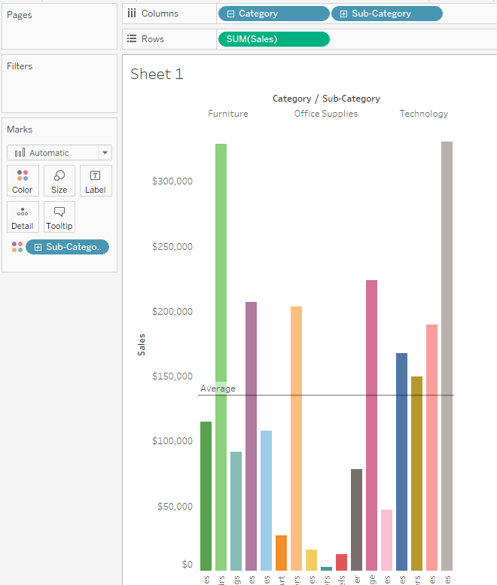

We can edit the Reference lines also,
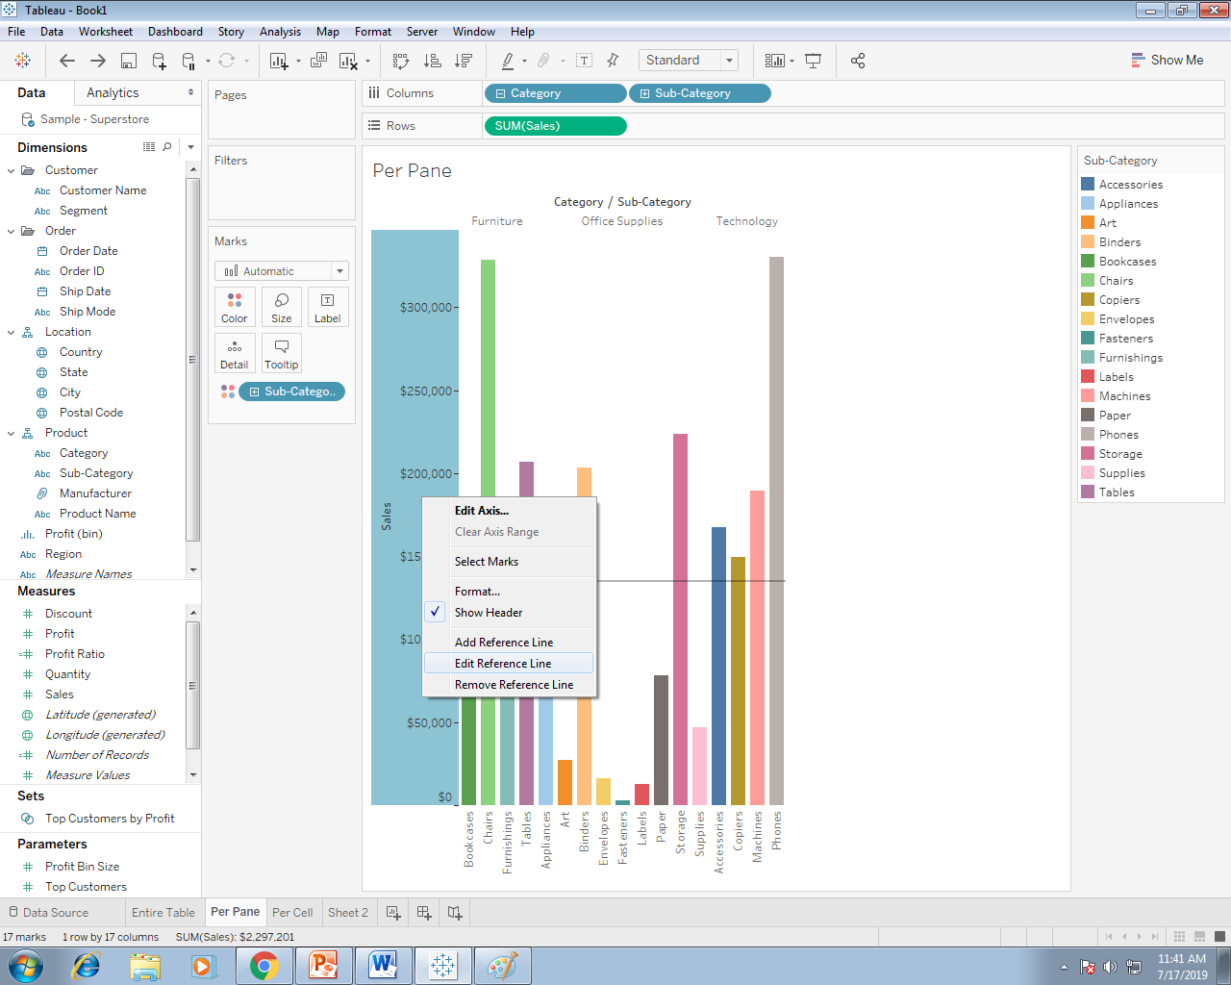

Here we can select the Per Pane and select Maximum sales on the Pane
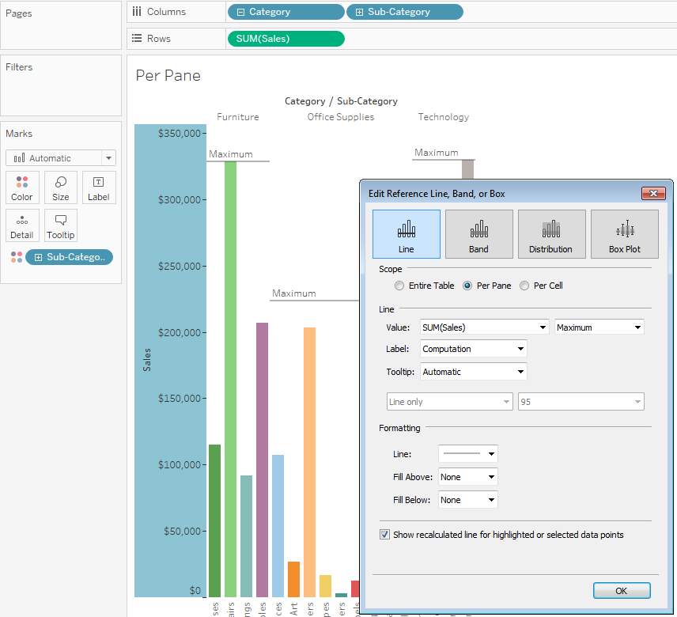

Here we select the Per Cell option.
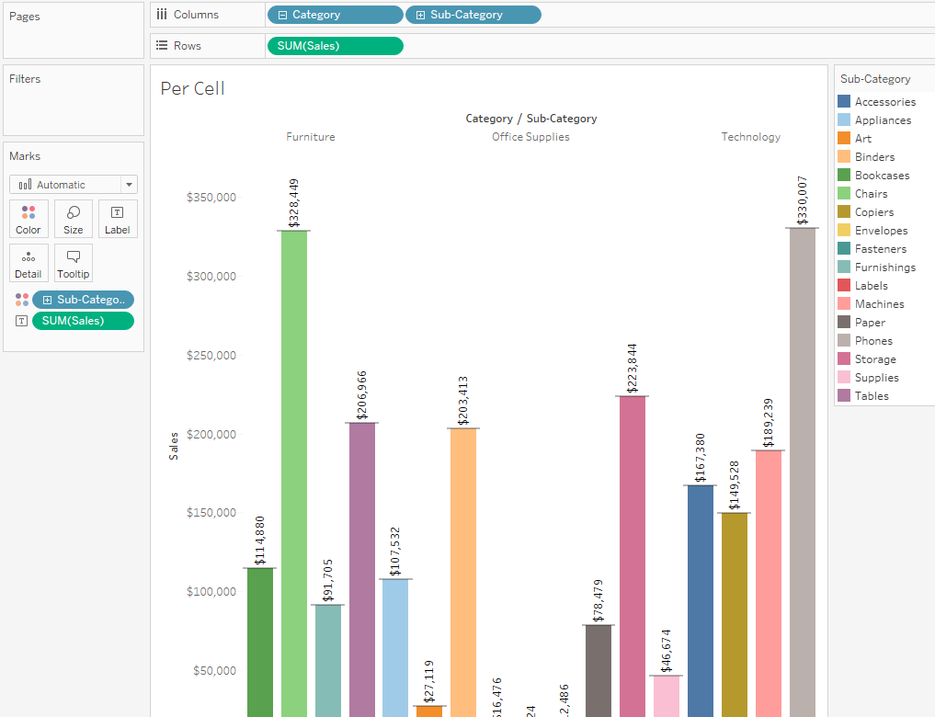

Edit Existing Reference Lines, Bands, and Distributions
You can edit existing lines, bands, or distributions. To do this, click on a line or on the outer edge of a band and choose Edit to reopen the edit dialog box for that object.

Remove Reference Lines in Tableau
In order to remove Reference Lines in Tableau, Right Click on the Sales Amount Axis will open the context menu. We have multiple options to remove reference Lines as shown below. For instance,
- If your tableau report holds only one Reference Line then you can select Remove Reference Line option.
- If your tableau report holds more than one Reference Line then you have to select Remove Reference Line option and then select the required reference line.
- Or, if you want to remove multiple Reference Line at one go then, you can simply select Remove All Reference Lines option.
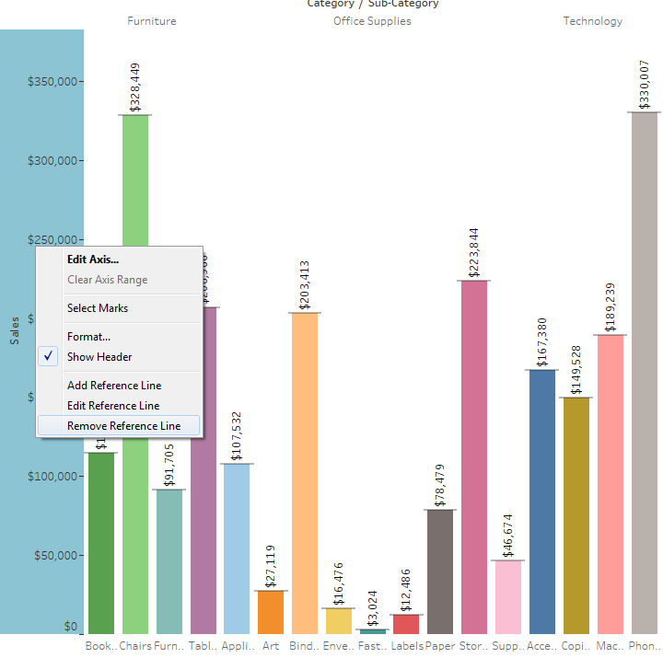

Reference Bands – >
Reference bands shade an area behind the marks in the view between two constant or computed values on the axis.
- Total - extends the band to a value that is at the aggregate of all the values in the cell, pane, or the entire view. This option is particularly useful when computing a weighted average rather than an average of averages. It is also useful when working with a calculation with a custom aggregation. The total is computed using the underlying data and behaves the same as selecting one of the totals option the Analysis menu.
- Sum - extends the band to a value that is at the SUM of all the values in either the cell, pane, or entire view.
- Constant- extends the band to a value that is at the specified value on the axis.
- Minimum - extends the band to a value that is at the minimum value.
- Maximum - extends the band to a value that is at the maximum value.
- Average - extends the band to a value that is at the average value along the axis.
- Median- extends the band to a value that is at the median value.
Select how you want to label the bands:
- None –select this option to not show a label for the reference band.
- Value – select this option to show a label corresponding to the band's value on the axis.
- Computation – select this option to display the name of the continuous field that is the basis for your reference band and any computation that is performed.
- Custom – select this option to build a custom label in the text box. You can use the menu to the right of the text box to insert values such as the computation or the value. You can also type text directly into the box, so you could create a value such as <Field Name> = <Value>.
Select how you want the tooltip to appear.
- None –select this option to not show a tooltip for the reference band.
- Automatic – select this option to show the default tooltip for the reference band.
- Custom – select this option to build a custom label in the tooltip. You can use the menu to the right of the text box to insert values such as the computation or the value. You can also type text directly into the box, so you could create a value such as <Field Name> = <Value>.

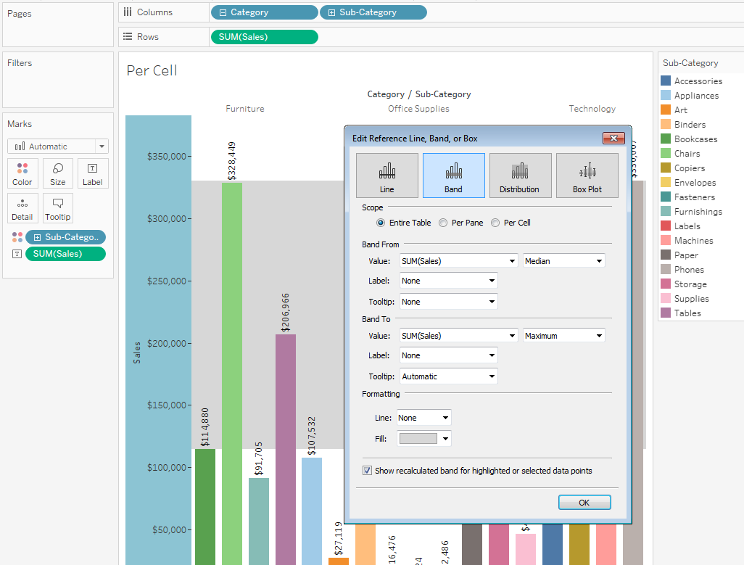

Shades an area behind the marks in the view between two constants or computed values on the axis.
Here Reference Band for entire table for Median sales per entire table.
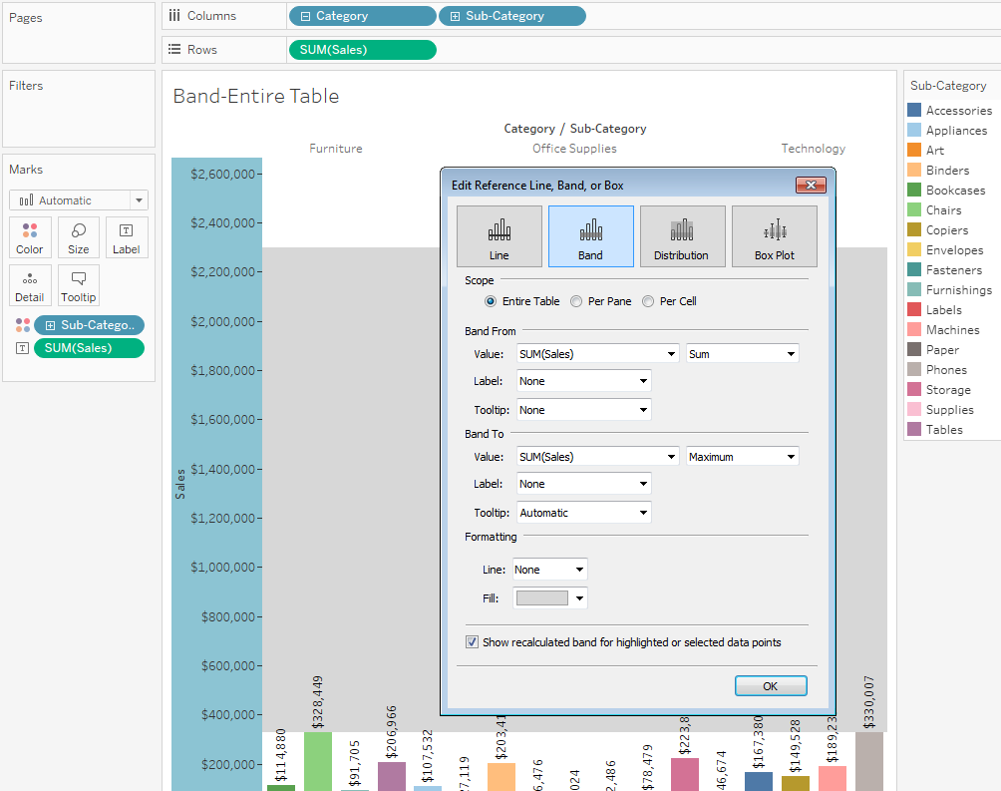

Banding for Entire table.
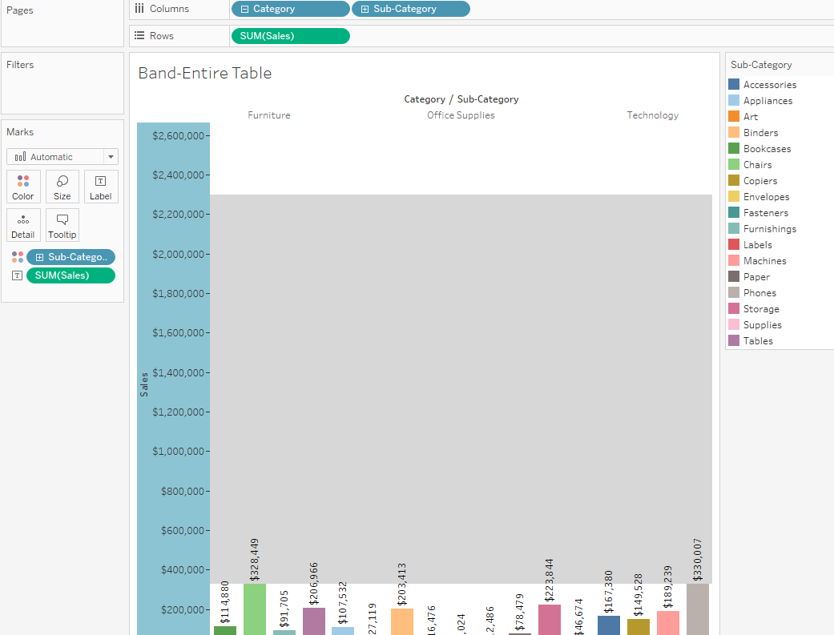

Banding for Per Pane and Average sales per Entire Table.
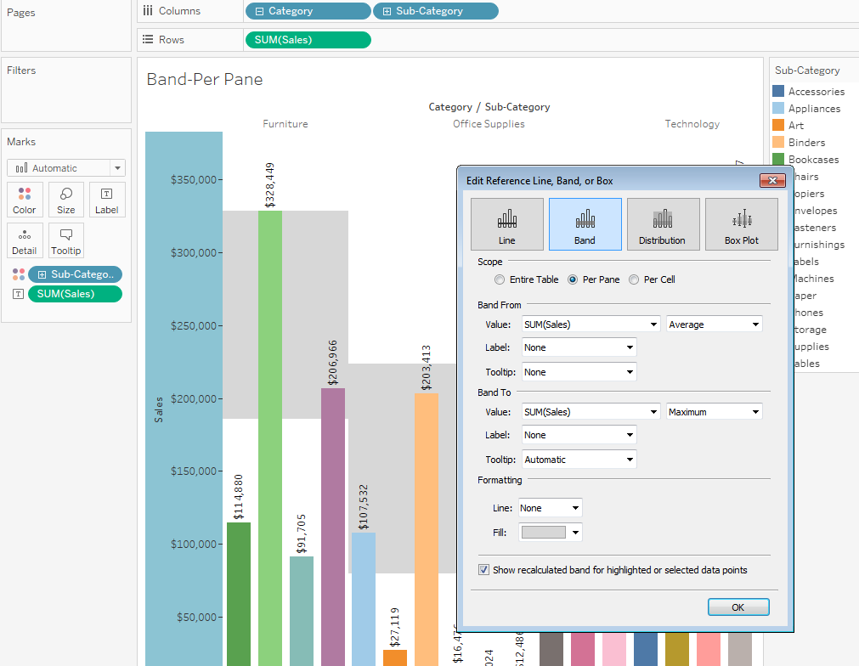
Here Banding for Average sum (sales) Per Pane.
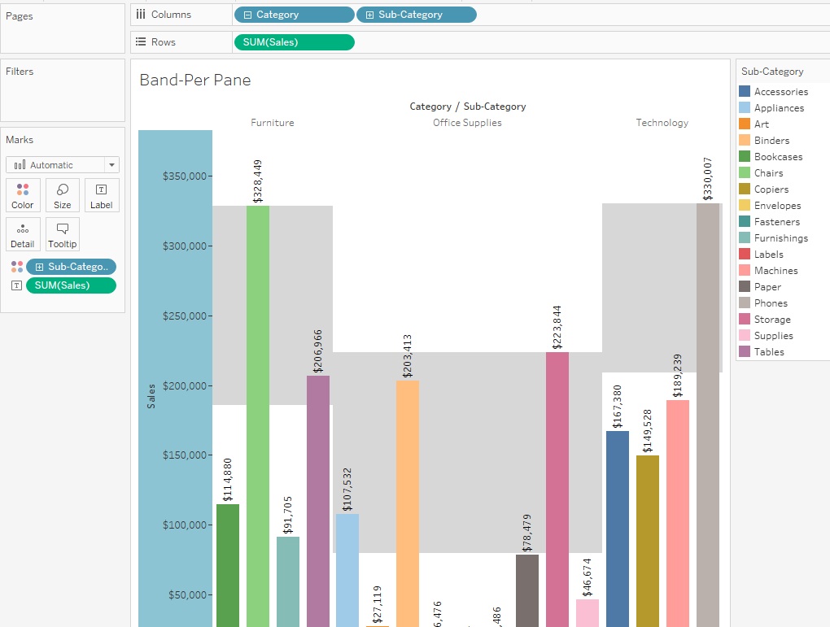

Banding for Per Pane
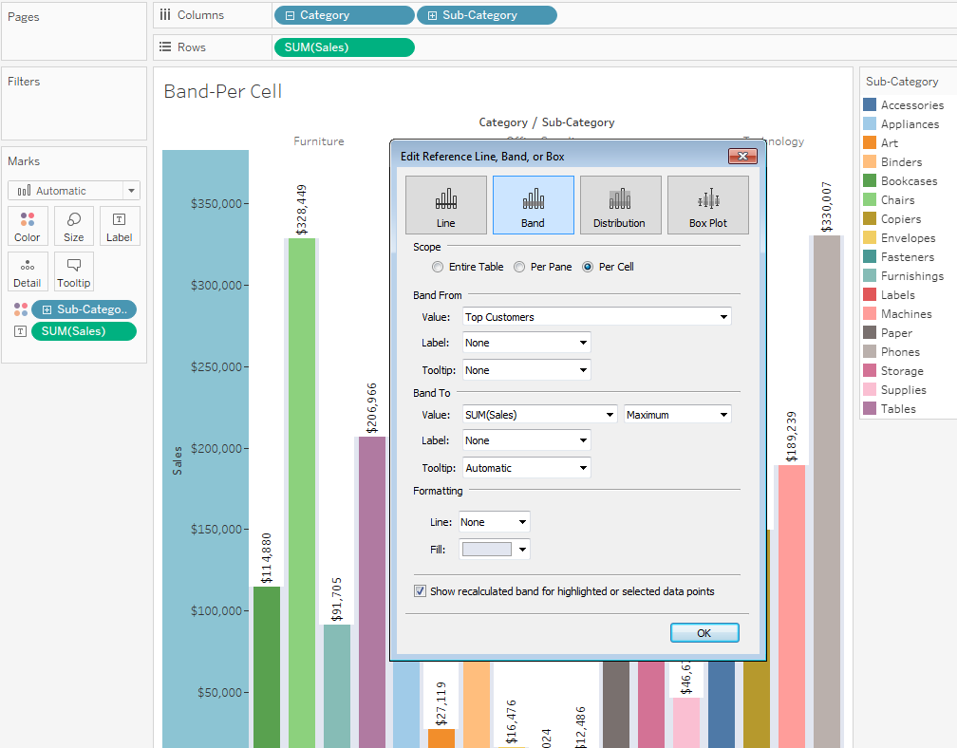
Banding For Per Cell
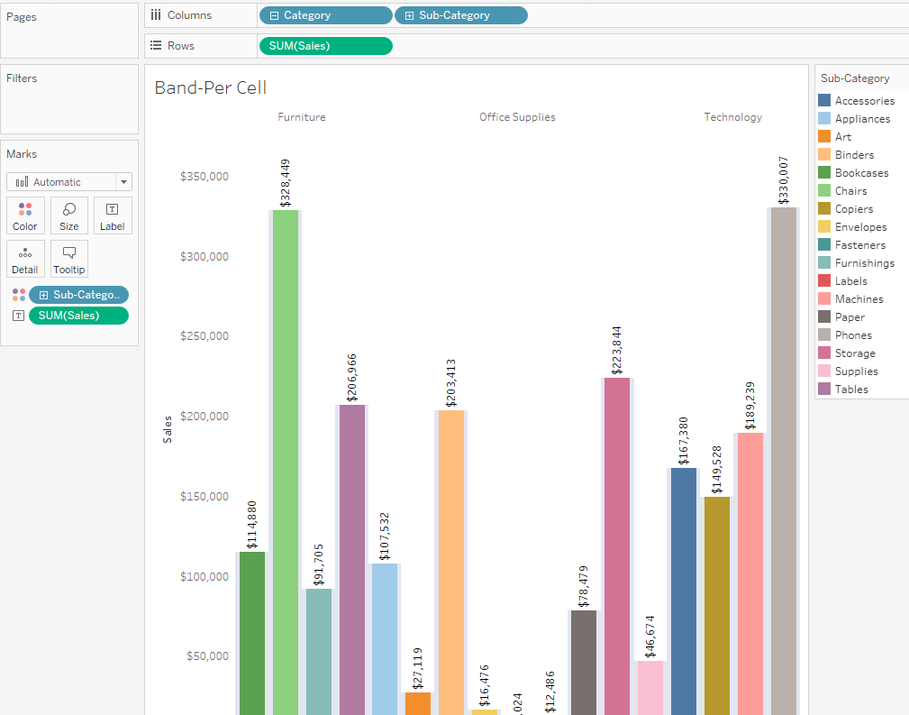

Here Banding for Sum (sales) Per Cell.
Reference Distributions –
Reference distributions add a gradient of shading to indicate the distribution of values along the axis. Distribution can be defined by percentages, percentiles, quantiles (as in the following image), or standard deviation.
Reference distributions are a variation of reference bands. A reference distribution adds a gradient of shading to indicate the distribution of values along the axis. Distributions can be defined by confidence interval, percentages, percentiles, quantiles, or standard deviation. In addition to the shading, you can add a line to mark a constant or computed value along the axis.
- Drag Distribution Band from the Analytics pane into the view. Tableau shows the possible destinations. The range of choices varies depending on the type of item and the current view.
- Select a scope for the distribution. The terms Table, Pane, and Cell define the scope for the item:
Select the computation that will be used to create the distribution:
- Percentages - shades the interval between the specified percentage values. Use a comma to separate two or more percentage values (for example, 60, 80), and then specify which measure and aggregation to use for the percentages.

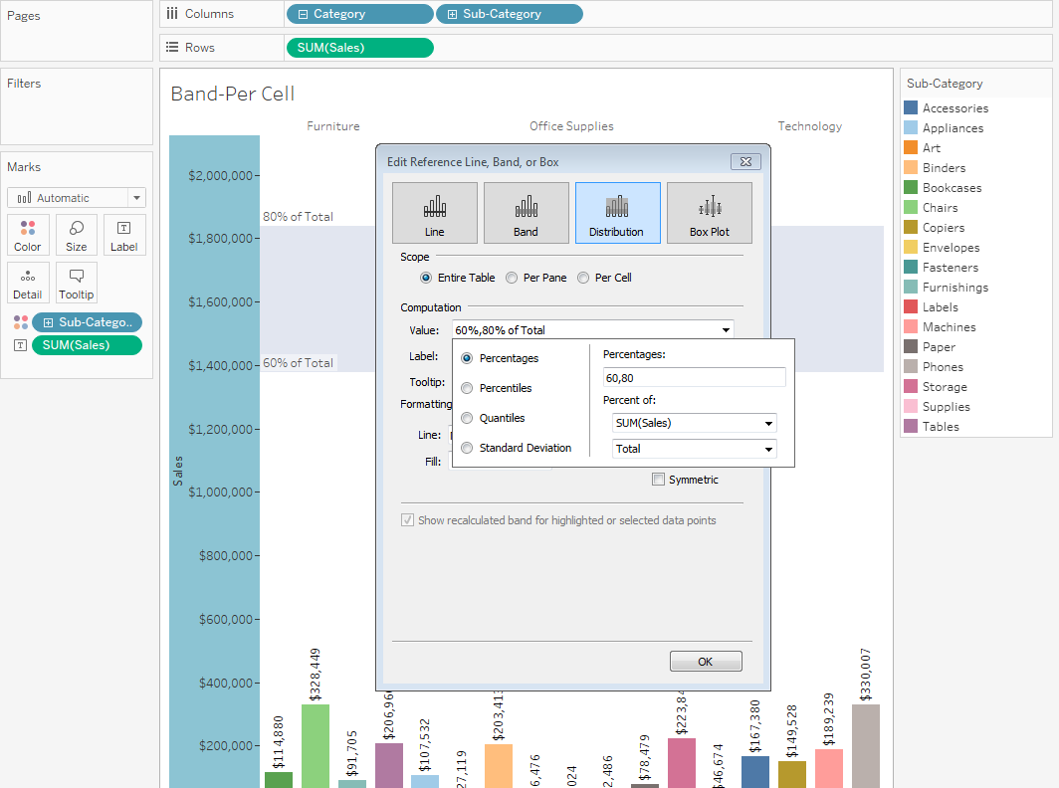
- Percentiles - shades intervals at the specified percentiles. Choose Enter a value from the Value drop-down list, and then enter two or more numerical values, delimited by commas (for example, 60,80 or 25, 50, 75).
- Quantiles - breaks the view into the specified number of tiles using shading and lines. When you select this computation, you must also specify the number of tiles (from 3 to 10, inclusive). For example, if you select 3, Tableau calculates the boundaries between the first, second and third terciles by calling the general quantile function and asking for the 33.33 and the 66.66 quantiles. It then shades the three terciles differently.
Tableau uses estimation type 7 in the R standard to compute quantiles and percentiles.
- Standard Deviation - places lines and shading to indicated the specified number of standard deviations above and below the mean. When you select this option you must specify the factor, which is the number of standard deviations and whether the computation is on a sample or the population.

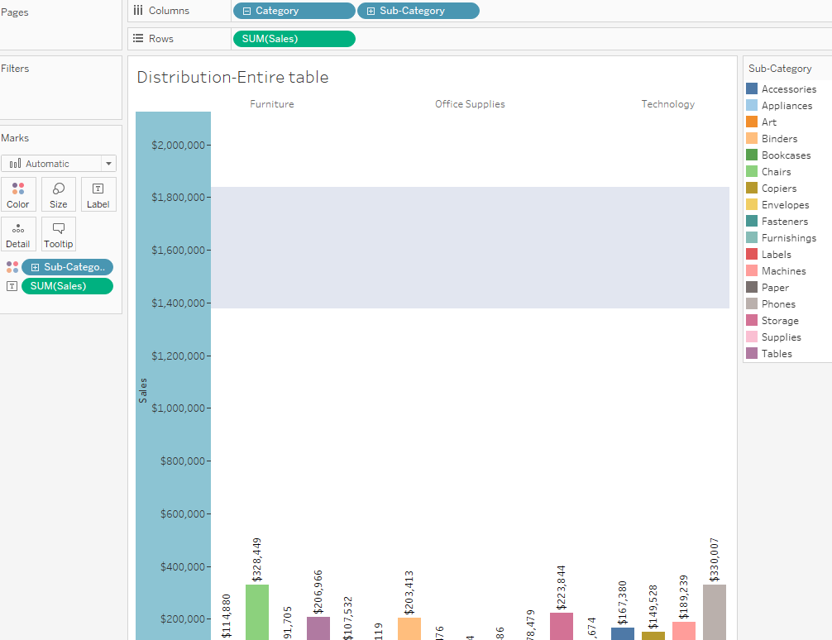
Specify how you want to label the distribution bands:
- None –select this option to not show a label for the distribution bands.
- Value – select this option to show a label corresponding to each distribution band's value on the axis.
- Computation – select this option to display the name of the continuous field that is the basis for your distribution bands and any computation that is performed.
- Custom – select this option to build a custom label in the text box. You can use the menu to the right of the text box to insert values such as the computation or the value. You can also type text directly into the box, so you could create a value such as <Field Name> = <Value>.

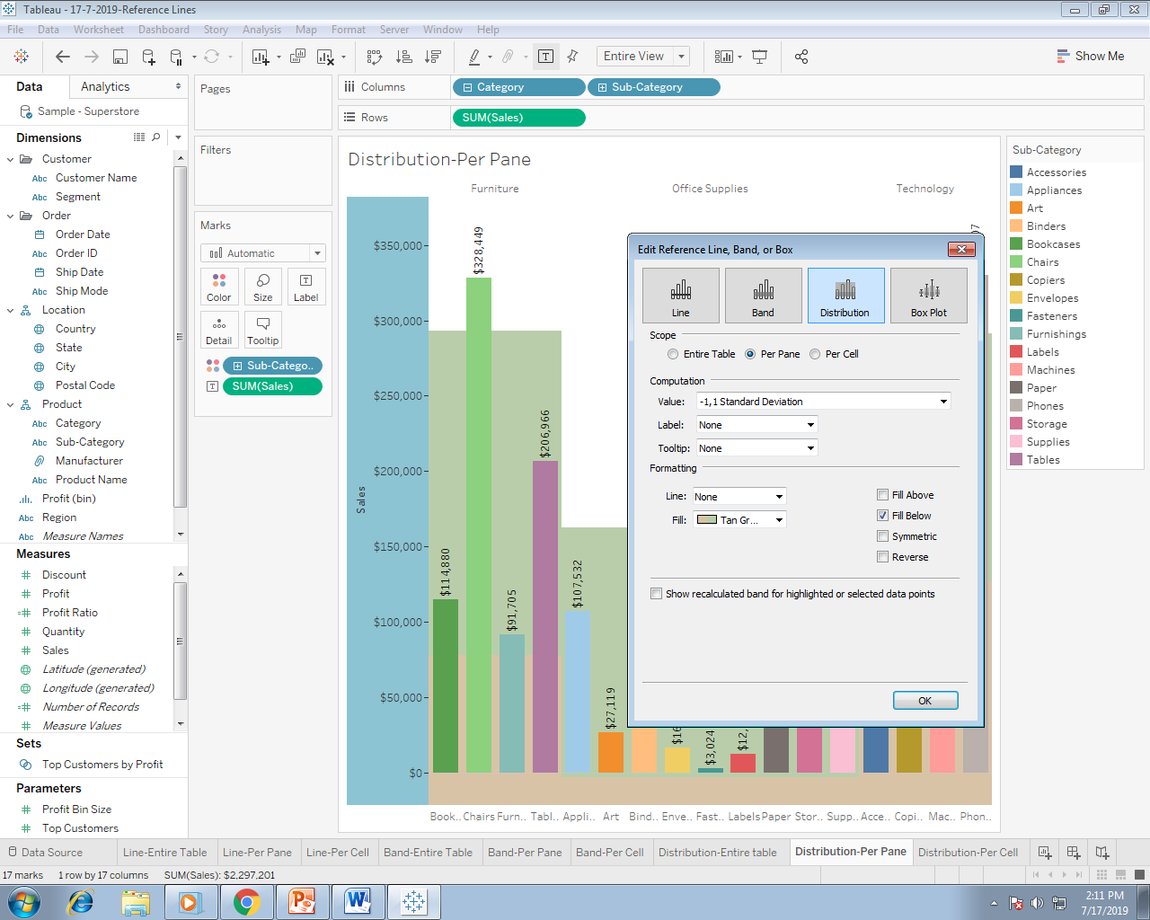

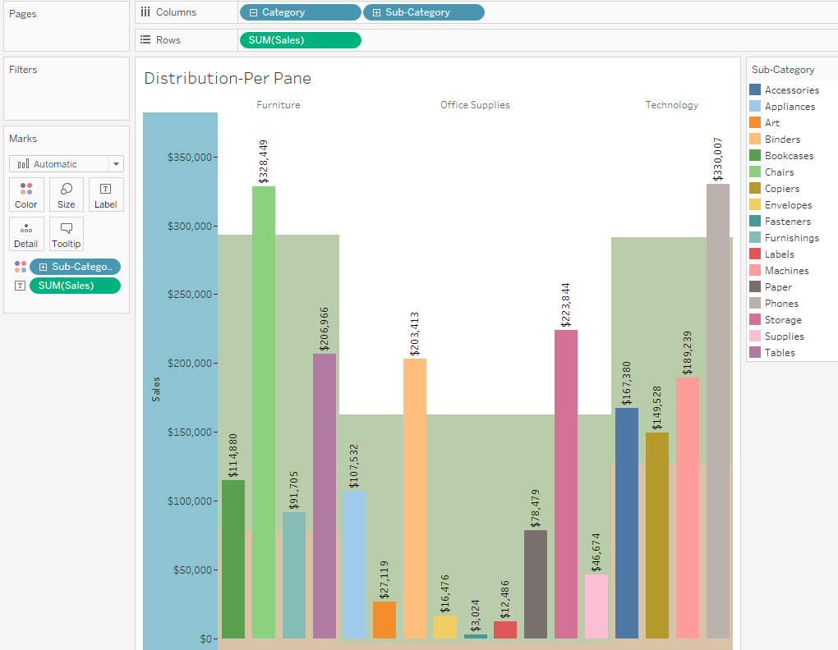

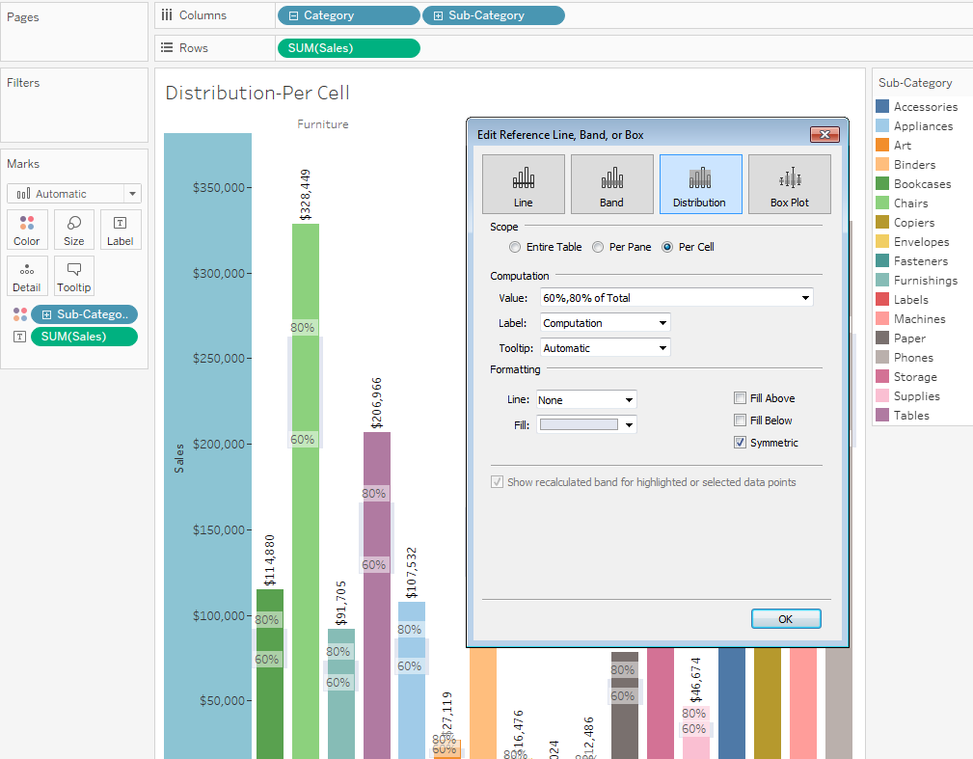

Here Distribution Per Cell wise Sales Percentages.
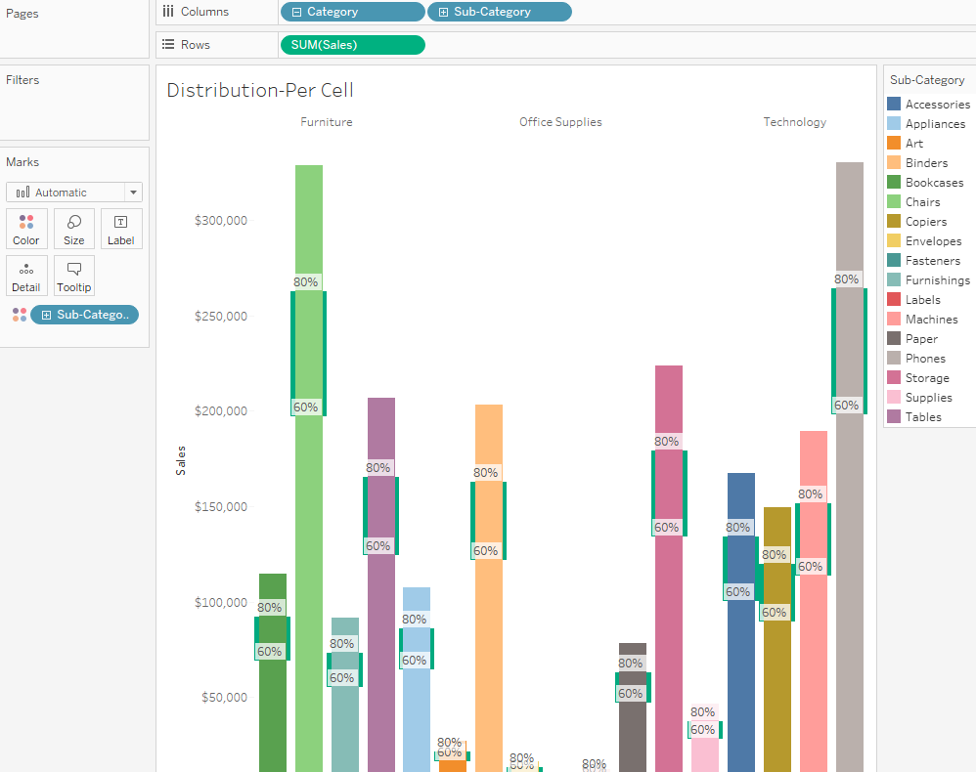

Box Plots –
Box plots (also known as box and whisker charts) are a standardized graphic for describing the distribution of values along an axis. Box plots show quartiles (also known as hinges) and whiskers. Tableau provides different box plot styles, and allows you to configure the location of the whiskers and other details.
Use box plots, also known as box-and-whisker plots, to show the distribution of values along an axis.
Boxes indicate the middle 50 percent of the data (that is, the middle two quartiles of the data's distribution).
You can configure lines, called whiskers, to display all points within 1.5 times the interquartile range (in other words, all points within 1.5 times the width of the adjoining box), or all points at the maximum extent of the data

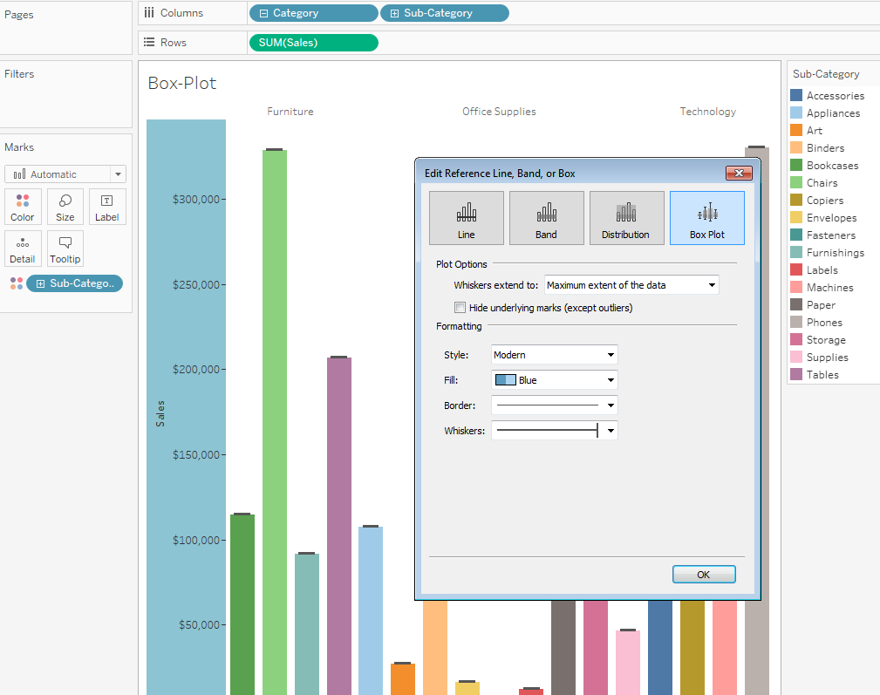

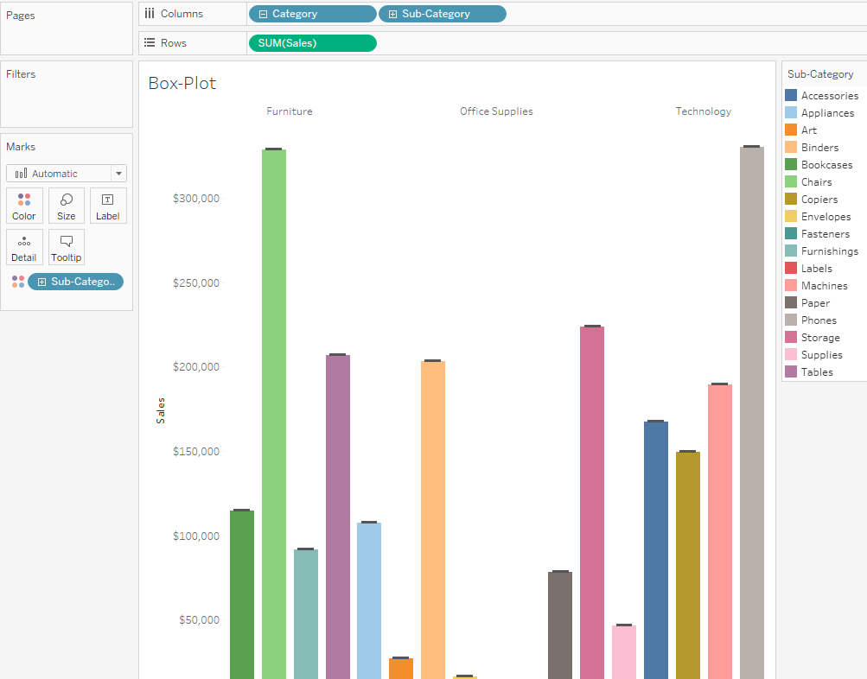

Here we can hide underlying Marks (except outliers).

Boxplots are also available from the Show Me pane when you have at least one measure in the view
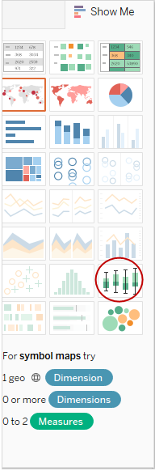
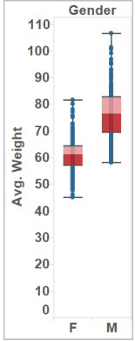
To add a box plot:
- Right-click (Control-click on a Mac) on a quantitative axis and select Add Reference Line.
- In the Add Reference Line, Band, or Box dialog box, select Box Plot.
- Under Plot Options, specify placement for the whiskers:

  - Data within 1.5 times the IQR - places whiskers at a location that is 1.5 times the interquartile range—that is, 1.5 times further out than the width of the adjoining box. This is also known as a schematic box plot.
  - Maximum extent of the data - places whiskers at the farthest data point (mark) in the distribution. This is also known as a skeletal box plot.

- Specify whether to hide underlying marks (except outliers)—that is, whether to hide all marks except those beyond the whiskers.
- Configure the appearance of the plot by selecting a Style, Fill, Border, and Whiskers.

